Me and My Community  Squirrel Class  Autumn 2026    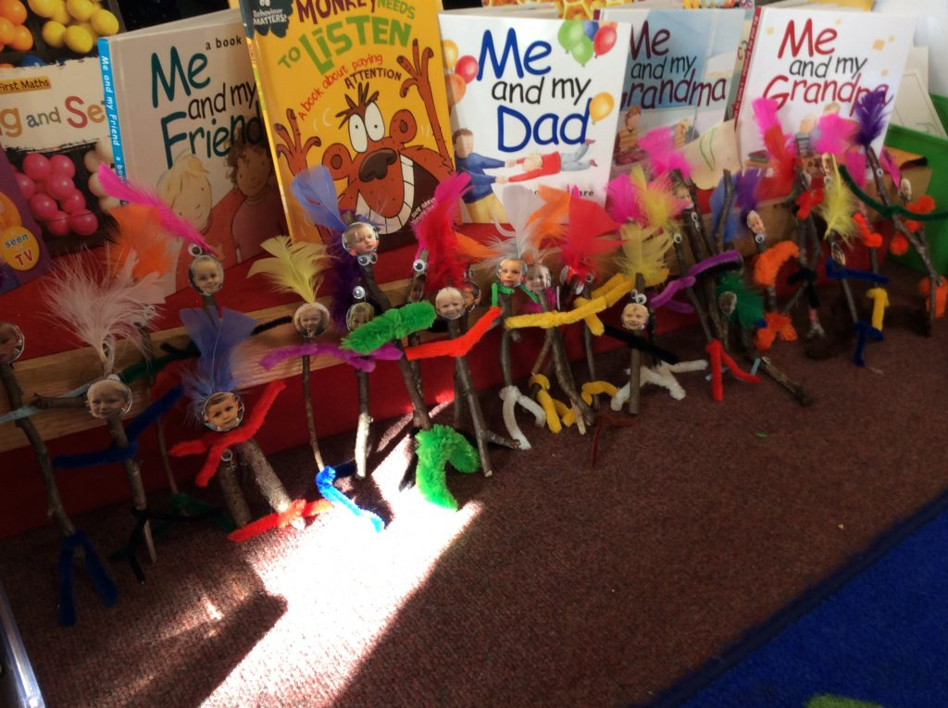 |  | Literacy |  | Maths
 |  | Literacy Learning Outcomes:  Enjoy sharing books, using props, costumes and story actions to retell class stories.  Enjoy the quality texts: ‘The Tiger Who Came To Tea’, ‘My Mum and Dad make me Laugh’, ‘My Cat likes to hide in Boxes’, ‘Pumpkin Soup’ and ‘The Little Red Hen’  Listen to a range of stories and use non-fiction books for information gathering. |  | Maths Learning Outcomes:  Know some number rhymes.  Play counting games, count at circle time, snack time.  Learn the days of the week rhyme.  Use money in the shop role play area  Make models and talk about the properties of 2D and 3D shapes
 |  | Skills Focus  Reading:  Begin to read individual letters by saying the sounds for them.  Begin to blend sounds into words.  Begin to read a few common exception words.  Begin to demonstrate and understanding of what has been read to them by retelling stories and narratives using their own words.  Use prepared provision in a variety of ways, and are interactive in role play.  Writing:  Show a preference for a dominant hand.  Begin to form lower case and capital letters correctly.  Use a pencil and hold it effectively using the tripod grip in almost all cases.  Apply phonic knowledge across a range of writing. |  | Skills Focus  KIRFS : Partition numbers to 5 into two groups  Number:  Count objects, actions and sounds.  Subitise up to 5.  Link the number symbol (numeral) with its cardinal number value.  Count beyond ten.  Compare numbers.  Understand the ‘one more/one less than’ relationship between consecutive numbers.  Explore the composition of numbers to 10.  Begin to recall number bonds for numbers 0-5 and some to 10.  Select, rotate and manipulate shapes to develop spatial reasoning skills.  Continue, copy and create repeating patterns.  Compare length, weight and capacity.
Understanding of the World |  | Communication and Language |  | Expressive Arts and Design
Skills:  Talk about members of their immediate family and community  Name and describe people who are familiar to them  Compare and contrast characters from stories, including figures from the past  Draw information from a simple map  Talk about the seasons and compare weather and the effects on animals and plants |  | Skills:  Understand how to listen carefully and why listening is important  Learn new vocabulary and use it throughout the day  Ask questions to find out more and to check they understand what has been said to them  Articulate their ideas and thoughts in well-formed sentences  Use talk to help work out problems and organise thinking. |  | Skills:  Explore, use and refine a variety of artistic effects to express their ideas and feelings  Create collaboratively, sharing ideas, resources and skills  Watch and talk about dance and performance art, expressing their feelings and responses  Safely use and explore a variety of materials, tools and techniques, experimenting with colour, design, texture, form and function
Vocabulary:  Family, mummy, daddy, sister, brother, friends, home, grandparents,  Insect, mini beast, autumn, conker, acorn, squirrel, hedgehog, butterfly, spider, ladybird, |  | Vocabulary:  Family, mummy, daddy, sister, brother, friends, home, grandparents,  Community, school, sharing, assembly, teacher, friends, kindness, giving, thankful, healthy |  | Vocabulary:  Colour, mix, paint, texture, brush, print, models, join, glue, scissors, create,  rhythm, patterns, loud, soft, tempo, rhyme
Learning Outcomes:  Self-portraits and family pictures  Talk about favourite people, places and toys  Find out about butterflies, ladybirds and spiders.  Take care of our woodland and finding out about the plants and animals that live there. |  | Learning Outcomes:  Use new vocabulary in different contexts  Listen carefully to rhymes and songs, paying attention to how they sound  Learn rhymes, poems and songs  Ask questions about our families, listening to each other’s experiences |  | Learning Outcomes:  Make use of props and materials when role playing characters in narratives and stories  Use junk to create own models  Explore paints and make self-portraits  Explore, use and make musical instruments
Physical Development | PSED |  | PE | Curriculum Enhancement
Skills  Progress towards a fluent style of moving, developing control and grace  Develop overall body strength, co-ordination, balance and agility  Develop their small motor skills so that they can use a range of tools competently, safely and confidently.  Confidently use a range of large and small apparatus indoors and outside, alone and in a group. | Skills:  See themselves as a valuable individual  Build constructive and respectful relationships  Express their feelings and consider the feelings of others  Show resilience and perseverance in the face of challenge  Identify and moderate their own feelings socially and emotionally |  | Learning Outcomes:  Children will have the opportunity to play on bikes, large boxes, climbing equipment, play starting and stopping games  During hall PE sessions the children will learn to use a variety of movements whilst listening to different types of music.  We will discuss routines; washing hands, bathing, brushing hair, eating healthy foods and why this is important for personal well-being. | Outdoor Learning:  Explore the natural world around them.  Describe what they see, hear and feel whilst outside.  Understand the effect of changing seasons on the natural world around them.  We will be exploring the woodland  We will be visiting the allotments  We will be taking care of our garden. We will water our flower beds. We will sort the rubbish we generate into recycling, compost and general waste
Vocabulary:  Roll, crawl, walk, jump, run, hop, skip, climb, scoop, weave, mould, firm, soft, pour, mix, draw | Vocabulary:  Friend, help, kind, share, fair, happy, sad, rules, safe |  | RE
 |  |  | Vocabulary:  Harvest, class worship, community, church, prayer  Learning Outcomes:  Recognise that people have different beliefs and celebrate special times in different ways.  We will be finding out about Harvest  We will be looking at Christian values and how these influence our lives. The children will be learning about new beginnings and how they can make positive changes through the year. We will also be discussing our Whole School Values and how these impact our learning. | Global Learning: “Healthy Food for a Healthy Planet”  This term the children will be celebrating Fairtrade Fortnight. They will also be exploring how what we choose to eat and the way we grow, produce and process our food has a huge impact not only on our health but also the health of our planet. This will be the theme for our Harvest Service at church.
Learning Outcomes:  Develop a range of ball skills: throwing, catching, kicking, passing, aiming  Negotiate space and obstacles safely, with consideration for themselves and others  Move energetically: running, jumping, dancing, hopping, skipping  Use tweezers and magnifying glasses  Make peg board pictures.  Use water wheels, scoops and funnels.  Make clay animals | Learning Outcomes:  In PSED children will follow our PSED ‘Jigsaw’ scheme and this term we will focus on the topic ‘Being Me in My World’ which concentrates on:  Understanding feelings  Being in the classroom  Being gentle  Rights and responsibilities
Values Education: “A Flourishing Community”
Through Collective Worship, we will be exploring what it means to be and do “community”, one of our North Leigh school values. We will be using bible texts alongside stories, both familiar and new to inspire reflection on themes that support healthy community living: diversity and belonging, empathy, self-esteem, collaboration and kindness.

